Name: Ashwin Yadav

Enrollment No: 232026900131

Subject: Frontend Development  
Date: 24-03-2025

Exam Type: Assignment

Q2 : - Make an web app which allows users to generate QR and barcode dynamically.(Make It downloadable)

Ans 1:

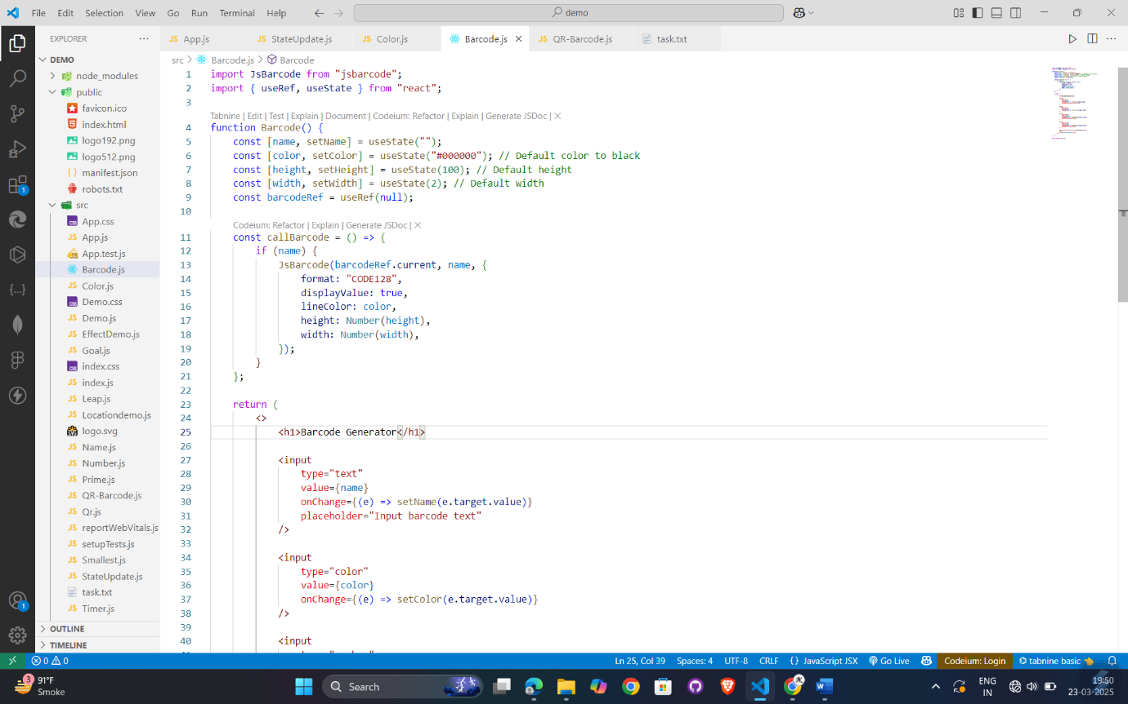

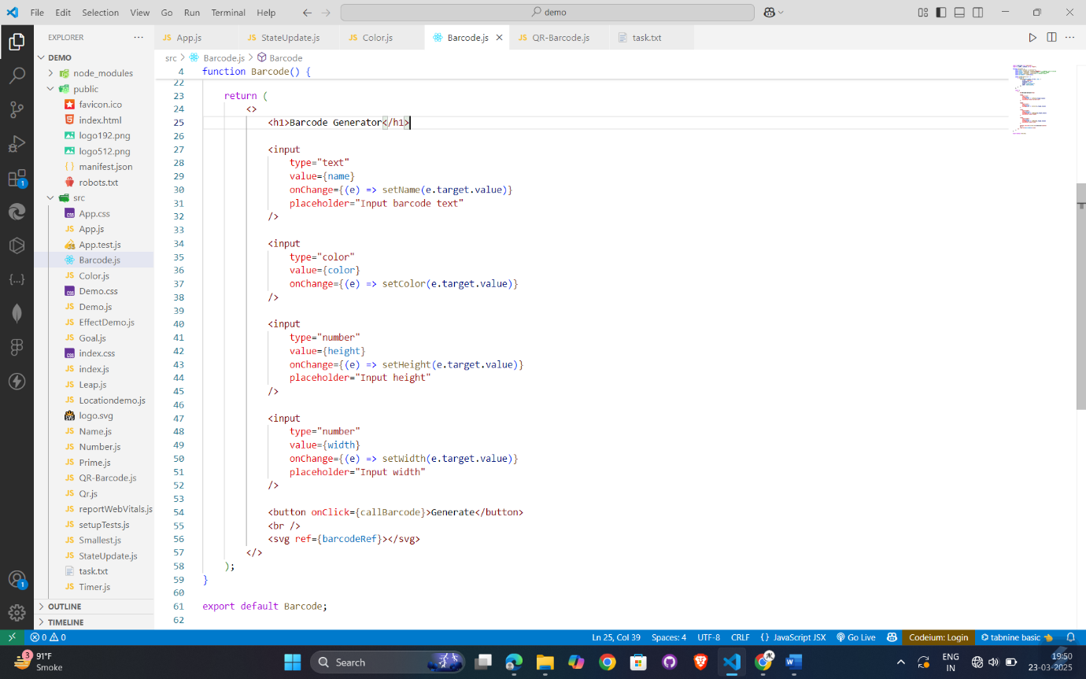

Output:

